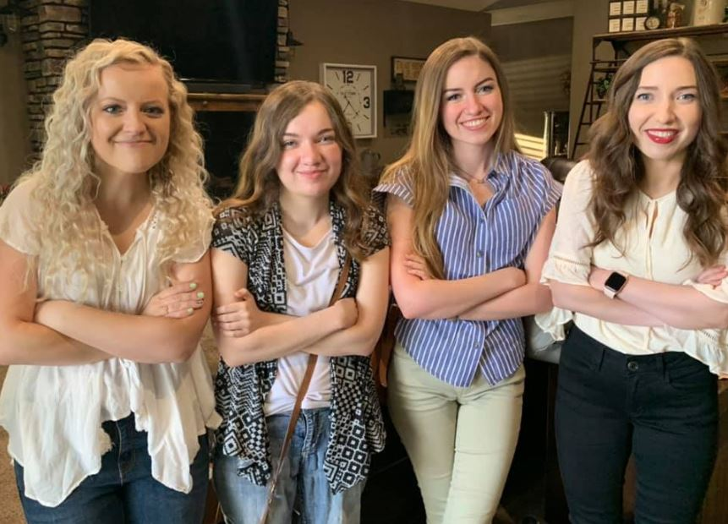

The picture is of me with people in my family; I am second on the left. My name is Hailey and I went to Wasatch High School in Heber. I’m not super athletic but I still like volleyball and softball just for fun. I love music and played the viola throughout high school. My favorite music to listen to is EDM. I am majoring in Animation and Game Design, which makes it obvious that I would be into games, movies and cartoons/anime. I love web comics and drawing/art. My career goal is to do 3D modeling (I’ll stay open, but so far I want that the most). Many people ask where I would like to work. I would love to work for Disney or Pixar, but even if I got into a smaller studio, I would still be very happy. I just want to be able to 3D model anything and everything basically. You guys can check out my art at <https://www.artstation.com/hstrobelt> if you are curious. Feedback is always welcome!